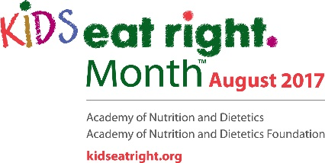
August is ‘Kids Eat Right’ Month

With childhood obesity on the rise, making sure kids eat right and get plenty of exercise is vital.

Parents and caregivers can play a big role in children’s nutrition and health, teaching kids about healthy foods, being a good role model and making sure physical activity is incorporated into each day.

August, which is Kids Eat Right Month, is a great time for families to focus on the importance of healthful eating and active lifestyles. The Academy of Nutrition and Dietetics is encouraging families to take the following steps:

Shop Smart. To encourage a healthy lifestyle, get your children involved in selecting the food that will appear at the breakfast, lunch or dinner table.

Cook Healthy. Involve your child in the cutting, mixing and preparation of meals. They will learn about food and may even be enticed to try new foods they helped prepare.

Eat Right. Sit down together as a family to enjoy a wonderful meal and the opportunity to share the day’s experiences with one another. Research indicates that those families who eat together have a stronger bond, and children have higher self-confidence and perform better in school.

Healthy Habits. You can help kids form great, healthy habits by setting a good example. Fill half your plate with fruits and vegetables, choose lower-sodium options, and make at least half the grains your family eats whole grains. For beverages, choose water over sugary drinks, and opt for fat-free or low-fat milk.

Get Moving. Aside from being a great way to spend time together, regular physical activity is vital to strengthen muscle and bones, promote a healthy body weight, support learning, develop social skills and build self-esteem. Kids are encouraged to be active for 60 minutes per day.

Getting kids to eat right can sometimes be a challenge, particularly if they are picky eaters. But experts say that a conversation can help.

“Talk to your children. Learn the foods they like. Teach them about the foods they need for their growing bodies. Find ways together to make sure they have the knowledge and ability to eat healthy and tasty foods at every meal,” says Angela Lemond, registered dietitian nutritionist and Academy of Nutrition and Dietetics spokesperson.

For more healthful eating tips, recipes, videos and to learn more about Kids Eat Right Month, visit www.KidsEatRight.org.

This August, reevaluate your family’s eating and exercise habits, and take steps to make positive, healthful changes.

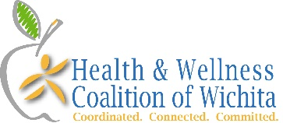
Brought to you by the Health & Wellness Coalition Healthy Eating Committee. For more information, contact Shelley Rich or visit our website.

