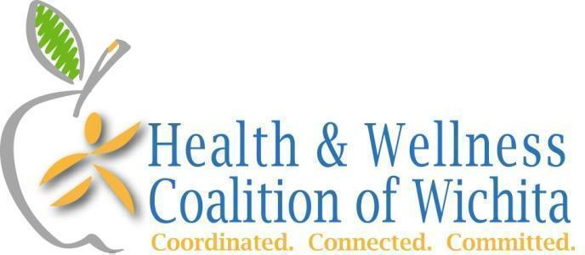

Meeting Summary
Tuesday, February 27th 2024, 2-3pm
K-State Research & Extension - Meadowlark Room

Our mission: Promote physical activity and good nutrition for every generation living in the greater Wichita area through people, programs, and policies.

Attending: 22 individuals representing 19 organizations

- Coalition Updates
  - 20th anniversary - share your story! Save The Date for a community celebration on 9/24 at OJ Watson Park. City of Wichita proclamation last week. Sedgwick County proclamation 3/6, come celebrate with us.
  - Food System Updates - ICT/SC Food & Farm Council next meeting March 5th. CHIP Food Access Workgroup good news - $3,000 awarded from LHEAT for food pantry client surveys.
  - Working Well Conference - Conference registration increases 3/15. Spread the word. We want to fill the new venue - The Vail.
  - Bike Month - Kick off event 4/28 Tour de Wichita. Save The Date for Bike to Work Day May 17th. Toolkit and challenge coming soon.
  - CELEBRATION!!!
    - $27,500 received in January from the Kansas Health Foundation for a sustainable business model consulting plan
    - $25,000 received TODAY from the Sunflower Foundation "Strengthening Our Section: Stronger Nonprofits for a Healthier Kansas." one of approximately 30 funded out of 300 applications to support the business model consulting project.

- Education: Sara Sawer & Amy Draut, K-State Research & Extension – Sedgwick County
  - The SNAP-Ed program is fully staffed and does Policy, Systems & Environmental work in addition to education.
  - Create Better Health - 3/7-4/11 4-5pm
  - Walk with East - 4/1-5/10 10-11am FREE, you do not have to have arthritis
  - Walk KS 3/31-5/25, registration opens March 4th. www.WalkKansas.org contact Amy if you can help promote.
  - Kitchen Restore community donation project. 250 kits have been distributed ($100-$125 value) If you are spring cleaning and want to donate, contact Sara.
  - Hypertension Awareness and Prevention program received a grant for self-monitoring blood pressure kits to check out at the Advanced Learning Library. Kits include self monitoring blood pressure equipment, toolkit in English and Spanish including how to take your blood pressure and education, blood pressure log.
  - Meal prep tips: Shop Simple with My Plate and Spend Smart, Eat Smart
  - Food Safety tips: Food Keeper app

- Networking/Good News/Upcoming Activities/Events
  - Health & Wellness Coalition Local Food Resource page - please share!
  - Michelle at Kansas Legal Services reported that they can host clinics to help people manage fines and fees.
  - Patty from USD 259 shared about Wichita Women for Good and grateful living gatherings starting in April once/month, 1 hour, Free
  - Angie with Ascension Via Christi Weight Management provides surgical and non surgical weight loss programs.
  - Daniel with WSU Environmental Finance Center is volunteering to help plan Bike Month including Bike to Happy Hour on Fridays.
  - Daisy with Aetna’s Sedgwick County Community Health Council is working with the ICT Community Fridge project. Currently seeking host sites for fridges.
  - Lianna with the YMCA shared that they offer LiveStrong for cancer survivors. 4th annual retreat is 4/26 for any cancer survivor.
  - Hillary with Mental Health Association of SC Kansas is hosting a Children’s Mental Health Day on May 4th emphasizing physical activity. Also 7 days of HOPE. Contact Hillary if you need a basic mental health presentation. Also partnering with KU Med for a certificate program for mental health. This free course is offered in 4 weeks, 40 hours. $1,000 stipend for completion.
  - Laurie with KSRE wants to assist food pantries with nutrition education.
  - Coach Stacy is an exercise, nutrition and mindset coach that offers virtual recordings to clients. Nutrient dense food line that will be shared with local pantries.
  - Robin with the Wichita Public Library is meeting with Amy about SNAP-Ed, looking at active programming (Zumba), the library will have 6 Storywalks by the end of the year!
  - Shae with the Sedgwick County Health Department promoted the Community Health calendar - post and look for health events. Also has space for programming.
  - Jessica is the Director of Mobility Management, gives presentations to the community. Promoting the Week without Driving in September and Kansas Mobility week in November.
  - Mary: ICT Food Rescue received a Wichita Women for Good grant. Looking to connect with a farmer who could use excess rescued food/potatoes. Great Plains Diabetes is hosting their monthly education session on 3/23.
  - Sarah recently moved back to Wichita. She is a dietician with a master’s in Exercise Science and is looking to connect.
  - Leah is an intern at WSU CEI.
  - Dulcy promoted the Salvation Army’s mobile pantries.
  - Danielle with Wichita Family Medicine mentioned their DPP class that is ongoing and their Matter of Balance and Healthy Heart classes that will begin in March.
  - Wendy with Wichita Family Medicine takes the information learned in these meetings and shares with patients. She recently printed off 4 pages of local parks and trails!

- Why We Do What We Do Two Economic Development topics this month:
  - https://ksoutdoors.com/State-Parks/Kansas-State-Parks-Economic-Contributions-to-Regional-and-State-Economies Be Physically Active! 6,809,562 visitors to state parks in 2021!
  - CEDBR booklets - Healthy, Wealthy and Wise
    - Health Promotion is IMPORTANT and matters in other circles!
    - What are your thoughts on how the HWC impacts economic development? What connections can be made?

- Closing, Call to Action & Completely Random Coalition Facts
  - Closing - next meeting March 26th
  - Call to Action - Network with someone new, SHARE what you learned.
  - Random fact - 12 orgs at the first meeting in 2004. Guess how many organizations/individuals are partnered with the coalition 20 years later? 222!

