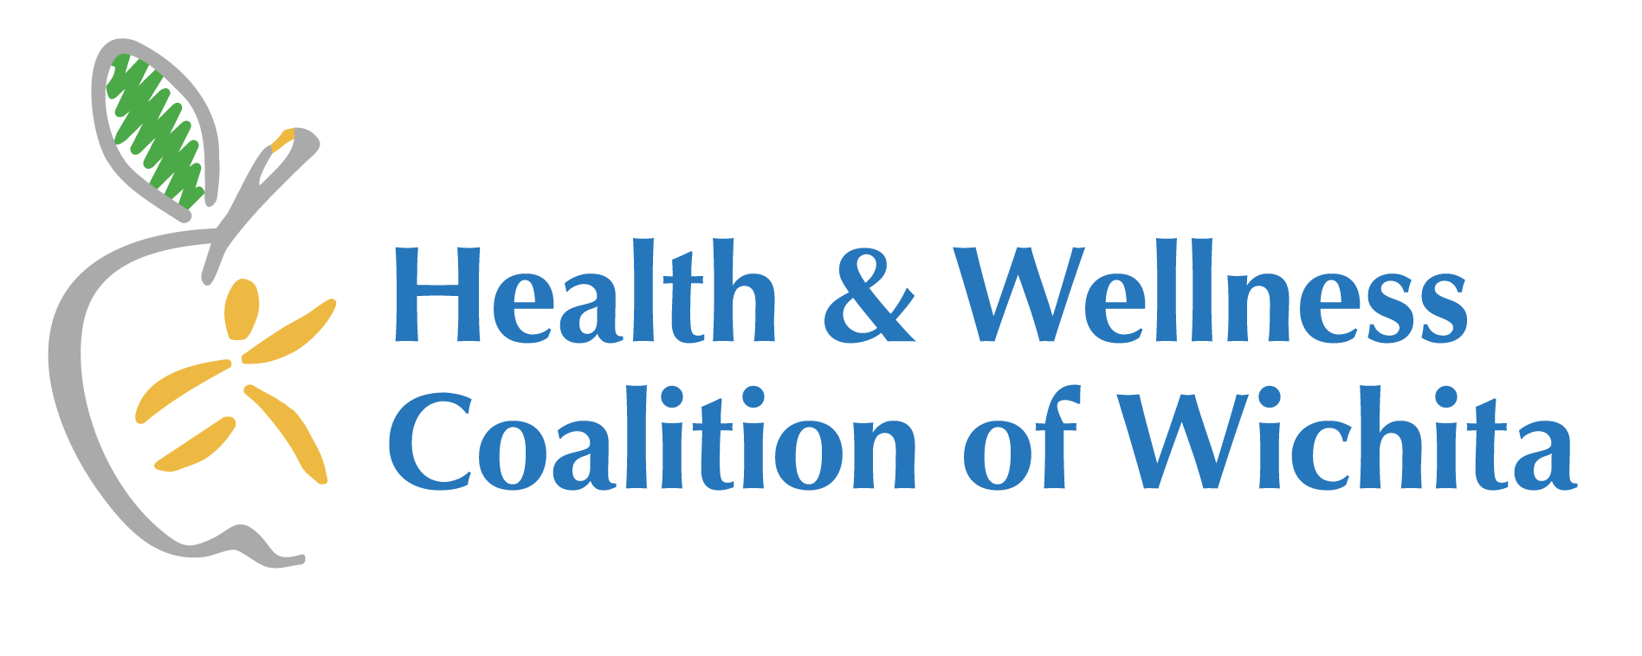
Meeting Summary
Tuesday, May 26th 2026, 2-3pm
Bike Walk Wichita, 325 N. St. Francis

Our mission: Promote physical activity and good nutrition for every generation living in the greater Wichita area through people, programs, and policies.

- Coalition Updates
  - Shelley reported back from the European Conference on Tobacco and Health and the way the tobacco industry is using it’s tactics with sports.
- Education about Bike Walk Wichita & Bike Month ICT was provided by Holly Terrill, Executive Director. The room we met in will be the new multipurpose classroom and is open to community meetings.
  - Holly pointed out the planning a route feature and the bike orientation checklist on the newly revised BWW website
  - Look. See. Save is work for a KDOT advocacy grant. The federal government is defunding biking and walking. You are invited to share your story.
  - Question - how old do you have to be to volunteer? The youngest started at age 9 with a parent, he is now 12 and comes twice a week after school.
  - Adults and teens can volunteer for 15 hours to earn a bike
  - Bike month is wrapping up and rolling right into Riverfest Bike Valet parking. Participants were encouraged to volunteer.
  - BWW and the HWC are partnering to encourage more businesses to apply to be a Bicycle Friendly Business. The Exploration Place applied. BWW is currently the only BFB in Wichita.
- Networking/Good News/Upcoming Activities/Events
  - Wyatt shared about their upcoming Picklepalooza and raffle.
  - Wendy shared that Walk with a Doc is back at Sedgwick County Park for the summer.
  - Lianna with the YMCA shared that100 cancer survivors attended their annual retreat and that she appreciated connections from the HWC for a couple of speakers. They are offering Cooking Matters for Parents this summer.
- Closing
  - Call to Action
    - HWC - Share what you learned from the meeting. Network with a community partner.
    - BWW - Volunteer for events. Ask yourself how you can help? Donate bikes?
- Facility Tour

Next meeting: Tuesday, June 23rd, 2026
Location: TBD



